Crowe Additional Reading

Some Preliminary Remarks
Michael J. Crowe

Question 1. Will we be doing history or science? In some ways, we will be doing neither and both! In particular, we will be doing history of science, which will involve taking a historical approach to learning about the development of the expanding universe theory. We shall also be considering religious aspects of our materials.
Question 2: Does the term “expanding universe theory” mean the same as the “big bang theory”? These terms are sometime used equivalently, but this is problematic. For example, the expanding universe theory was first put forward in 1927 and the big bang theory came forth only in 1931 and in a sense even later than this. In fact, the label “Big Bang” was introduced only in 1949, eighteen years after the theory had been introduced. Moreover, it was fully accepted only after about 1965. What’s the difference scientifically? The expanding universe theory is the claim that the galaxies are moving away from us at a speed that is proportional to their distance from the Earth. On the other hand, the big bang theory is the claim that at a very remote time in the past, all the matter in the universe was in a small object, which exploded with extraordinary force and that the motion of the matter continues to the present. Note that “Big Bang Theory” includes the “Expanding Universe Theory.”
Question 3: Who created this theory? In attempting to answer this question, you might consult the Encyclopaedia Britannica. If you did this, you would find that after explaining correctly that Edwin Hubble in 1924 had determined that the universe contains remote galaxies more or less comparable to our own Milky Way galaxy, the EB reports:

In studying the galaxies, Hubble made his second remarkable discovery—namely, that these galaxies are apparently receding from the Milky Way and that the further away they are, the faster they are receding…. The implications of this discovery were immense. The universe, long considered static, was expanding; and, even more remarkably, as Hubble discovered in 1929, the universe was expanding in such a way that the ratio of the speed of the galaxies to their distance is a constant now called Hubble’s constant.

Many other otherwise reliable resources made the same claim. The evidence is now clear that this claim is incorrect. In fact, Hubble was fairly negative about some key aspects of theory, especially the big bang aspects of the theory. For a compelling presentation of this claim, see the publication in footnote 1. For evidence that the claims made by these two authors are widely accepted, see the bibliography for this unit.
Question 4: How important is the discovery of the Big Bang theory? I agree with the following claim: “The theory of the Big Bang universe has dominated cosmology for more than half a century and has long ago acquired paradigmatic status. It is generally considered to be one of the most important events in the history of cosmology ever, easily comparable with, say, the Copernican revolution.”
Comment: The Hubble constant. One potentially major source of confusion in these materials centers on a very simple equation. It is the equation V = HD. This equation is the equation that relates the velocity V of any galaxy to its distance D from the Earth. If you know the velocity of the galaxy (which is usually determined by a spectroscope) and the value of H, then you can determine the distance of that galaxy from the Earth. All this seems simple enough. Historically it was quite difficult to get a good value for H! We regularly encounter numerical estimates that may be off by 1% or less. What will happen from 1929 to the present is that values for H will change by a factor of about 10! Hubble’s value for H in 1929 was about 500 kilometers per second per million parsecs (a parsec is the distance that a beam of light travels in one second). The current value of H is about 75 million parsecs per second. One implication of this is that we need to look at some of the developments that led to the drop in the magnitude assigned to H. One way in which this is very important is that it is through H that we calculate the age of the universe.
Question 5: What will I learn from these materials? The materials I have designed for our two classes are such that it will provide you a basic understanding of what is a candidate for the most important discovery made in the 20th century. This is the Big Bang theory. It will also provide you with an understanding of the surprising history of how humans came to this staggeringly broad theory. The materials are also designed to help you know your way around our universe and to give you some quantitative sense of the distances and magnitudes involved. We shall also look at various religious issues, some quite surprising, involved in this topic.
Question 6: What will be the format for the class? You are being asked to read about thirty pages of materials before the class begins. Then in our two meetings I will have a colorful PowerPoint presentation drawing all these materials together.

P.S. I am delighted by the number of persons who have signed up for the 2016 PLS Summer Symposium. Moreover, I am delighted by the quality of the participants. Having taught many of those enrolled, I am especially looking forward to seeing you again.

Georges Lemaître’s 9 May 1931 Paper
(M. J. Crowe)

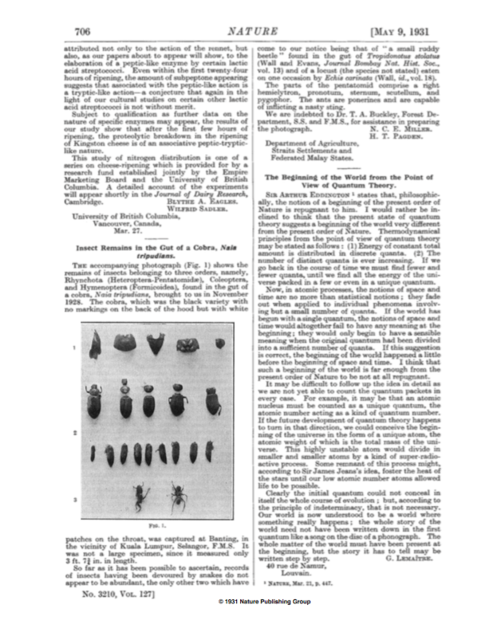
A short paper (actually it was a letter) by Abbe Georges Lemaître appeared in the May 9, 1931 issue of the English scientific journal named Nature. The paper is now seen as one the most important scientific publications in the twentieth century. This paper is the cornerstone of the claim that the Lemaître was the first to publish the Big Bang theory of the universe. As can be seen in the image of the paper at the right, it was not a long paper (only 472 words). Nor was its setting very striking. The longer illustrated paper to its left is rather unremarkable. It was titled “Insect Remains in the Gut of a Cobra.” Moreover, Lemaître signed his paper using only his name and his street address; he made no mention of the fact that he was a professor at Louvain University with two doctorates.
The background for the paper is that earlier in 1931, the prominent English astronomer Arthur Stanley Eddington, who had called attention to the great importance of Lemaître’s 1927 paper on the expanding universe, published in Nature a long paper titled “The End of the World: From the Standpoint of Mathematical Physics.” In it, Eddington stated: “Philosophically, the notion of the beginning of the present order of Nature is repugnant to me.” In other words, he was noting that he could not believe that the universe had a temporal origin; rather it had always existed. This was the view that scientists typically held at that time. A transcription of Lemaître’s response follows this page.
One is tempted to say about Lemaître’s paper that it created a Big Bang, but this would be far from the truth. It would be correct, however, to state that eventually this paper was recognized as having created the Big Bang theory.

Georges Lemaître, “The Beginning of the World from the Point of View of Quantum Theory,” Nature, 127 (9 May 1931), 706.

SIR ARTHUR EDDINGTON states that, philosophically, the notion of a beginning of the present order of Nature is repugnant to him. I would rather be inclined to think that the present state of quantum theory suggests a beginning of the world very different from the present order of Nature. Thermodynamical principles from the point of view of quantum theory may be stated as follows: (1) Energy of constant total amount is distributed in discrete quanta. (2) The number of distinct quanta is ever increasing. If we go back in the course of time we must find fewer and fewer quanta, until we find all the energy of the universe packed in a few or even in a unique quantum.
Now, in atomic processes, the notions of space and time are no more than statistical notions; they fade out when applied to individual phenomena involving but a small number of quanta. If the world has begun with a single quantum, the notions of space and time would altogether fail to have any meaning at the beginning; they would only begin to have a sensible meaning when the original quantum had been divided into a sufficient number of quanta. If this suggestion is correct, the beginning of the world happened a little before the beginning of space and time. I think that such a beginning of the world is far enough from the present order of Nature to be not at all repugnant. It may be difficult to follow up the idea in detail as we are not yet able to count the quantum packets in every case. For example, it may be that an atomic nucleus must be counted as a unique quantum, the atomic number acting as a kind of quantum number. If the future development of quantum theory happens to turn in that direction, we could conceive the beginning of the universe in the form of a unique atom, the atomic weight of which is the total mass of the universe. This highly unstable atom would divide in smaller and smaller atoms by a kind of super-radioactive process. Some remnant of this process might, according to Sir James Jeans’s idea, foster the heat of the stars until our low atomic number atoms allowed life to be possible. Clearly the initial quantum could not conceal in itself the whole course of evolution; but, according to the principle of indeterminacy, that is not necessary. Our world is now understood to be a world where something really happens; the whole story of the world need not have been written down in the first quantum like a song on the disc of a phonograph. The whole matter of the world must have been present at the beginning, but the story it has to tell may be written step by step.
Georges Lemaître
40 rue de Namur, Louvain.

Some Commentary
What were Lemaître’s reasons for advocating his big bang theory of the formation of the universe?
1. Lemaître and then Edwin Hubble had already recognized that the galaxies all around us are now moving away from us at speeds proportional to their distance from us. This is compatible with the idea that long ago their material and the material eventually composing the Earth were in one relatively small area.
2. Lemaître was well aware of radioactive materials, which would gradually break down or decay tossing off other chemical elements in different directions. Thus it might be that a comparable process proceeded to act in the universe as a whole.
3. Nineteenth-century physicists had developed the notion of entropy, which is a measure of the unavailability of useful energy. This led to the idea (the second law of thermodynamics) that the availability of useful energy in the universe was constantly decreasing. If the universe were eternal, the entropy of the universe would increase to the point that no useful energy would be available. Clearly this had not yet happened.
Lemaître followed up on his May 9, 1931 paper with another paper dated October 24, 1931 in which he developed his idea further and introduced such important and expressive terms as “fireworks theory” and “Primal atom.” In this paper, he states: “A complete revision of our cosmological hypothesis is necessary, the primary condition being the test of rapidity. We want a ‘fireworks’ theory of evolution. The last two thousand million years are slow evolution; they are ashes and smoke of bright but very rapid fireworks.” He also states: “If the total time of evolution did not exceed, say, ten times that age of the earth, it is quite possible to have a variation of the radius of the universe going on, expanding from zero to the actual value. I would picture the evolution as follows: at the origin, all the mass of the universe would exist in the form of a unique atom; the radius of the universe, although not strictly zero, being relatively very small. The whole universe would be produced by the disintegration of this primeval atom.”
A striking contrast exists between the reception of Lemaître’s expanding universe theory, which after 1931 seems to have been widely accepted, and the reception of the big bang aspect of the theory, which he first published in 1931 and that won the day only in 1965 after the detection by Penzias and Wilson of the 3° Kelvin background radiation. It is somewhat hard to assess how the community of physicists and astronomers reacted to the theory he put forth in his 9 May 1931 Nature essay. Here is a summary by two experts in this area:
The conceptual novelty of Lemaître’s hypothesis may be illuminated by looking at how it was received by physicists and astronomers shortly after its introduction in 1931. It took some time until it was noticed at all, probably a result of Lemaître’s decision to publish his primeval-atom model in French in Revue des Questions Scientifiques, a semi popular journal unknown to most physicists and astronomers although well known among Catholic scientists. When it did become known, the general response was either dismissal or neglect, in a few cases even ridicule. John Plaskett, a Canadian astronomer, concluded that Lemaître’s fireworks theory was “the wildest speculation of all . . . an example of speculation run mad without a shred of evidence to support it”. The verdict of Ernest Barnes, the mathematically trained Bishop of Birmingham, was not much different: “I do not think that many cosmogonists have yet been persuaded by the theory of Lemaître. It is usually regarded as a brilliantly clever jeu d’esprit rather than a sober reconstruction of the beginning of the world”. Or consider Tolman, who in his textbook of 1934 found it necessary to warn against ‘the evils of autistic and wishfulfilling thinking’ in cosmology, to which he counted the belief that the universe was created in the past. There can be little doubt that he thought of Lemaître, when he wrote: “The discovery of models, which start expansion from a singular state of zero volume, must not be confused with a proof that the actual universe was created at a finite time in the past”.
In coming to an understanding of the place of Lemaître’s writings in the history of the big bang theory, I have been helped by reading a paper published by a Harvard astronomer Donald Menzel in 1932 in Popular Science Monthly, which was not a scholarly journal. This essay presents Lemaître’s claims in a format that the public could understand and read with wonderment. I am including it at this point not only because it is interesting, but also because the claims it makes coincide for the most part with the present day Big Bang theory. It is important to understand that until about 1965, the scientific community did not accept the Big Bang claims made in this paper. Of course, we will explain how this very striking theory eventually attained acceptance.

Donald Menzel’s Essay “Blast of Giant Atom Created Our Universe,” Popular Science Monthly, (Dec., 1932), 28–29, 103.
Note: Apologies for the small type. Do not feel obliged to read the entire text, but note the introductory paragraphs, the diagrams, and tone of Menzel’s paper. Although published in 1932, it provides a good picture of the Big Bang theory.

Helge Kragh and Robert Smith, “Who Discovered the Expanding Universe?” History of Science, 41 (2003), 41 (2003), 141–62:141.
Helge Kragh and Dominique Lambert, “The Context of Discovery: Lemaître and the Origin of the Primeval Atom Hypothesis,” Annals of Science. 64 (2007), 445–70:445.
Nature, Mar. 21, p. 447.
Georges Lemaître, “Contribution to the British Association Discussion of the Evolution of the Universe,” Nature, 128 (Oct. 24, 1931), 705.
Lemaître, “Contribution,” Nature, 128 (Oct. 24, 1931), 706.
Helge Kragh and Dominique Lambert, “The Context of Discovery: Lemaître and the Origin of the Primeval Atom Hypothesis,” Annals of Science, 64 (2007), 445–70:458.
Donald Menzel, “Blast of a Giant Atom Created Our Universe,” Popular Science Monthly, 121 (Dec., 1932), 28–29, 105.

